ST. XAVIER’S COLLEGE

**(Affiliated to Tribhuvan University)**

Maitighar, Kathmandu



**Computer Graphics Lab Assignment #9**

**Sharing**

**Submitted by:**

Divya Jyoti Pokharel

013BSCCSIT019

**Submitted to:**

|  |  |
| --- | --- |
| Er. Anil Sah  Lecturer, St. Xavier’s College |  |

**Statement:**

Program for sharing.

**Source code:**

//---------------------------------------------------------------------------

#include <vcl\vcl.h>

#pragma hdrstop

#include "Unit1.h"

//---------------------------------------------------------------------------

#pragma resource "*.dfm"

TForm1 *Form1;

//---------------------------------------------------------------------------

__fastcall TForm1::TForm1(TComponent* Owner)

: TForm(Owner)

{

}

//---------------------------------------------------------------------------

void __fastcall TForm1::scaleClick(TObject *Sender)

{

int i,j;

float sx,sy;

int h=input->Height;

int w=input->Width;

sx=StrToFloat(inX->Text);

sy=StrToFloat(inY->Text);

int a,b;

for(i=0;i<=h;i++){

for(j=0;j<=w;j++){

a=i+sx*j;

b=j+sy*i;

output->Canvas->Pixels[a][b] = input->Canvas->Pixels[i][j];

}

}

}

//---------------------------------------------------------------------------

**Output**

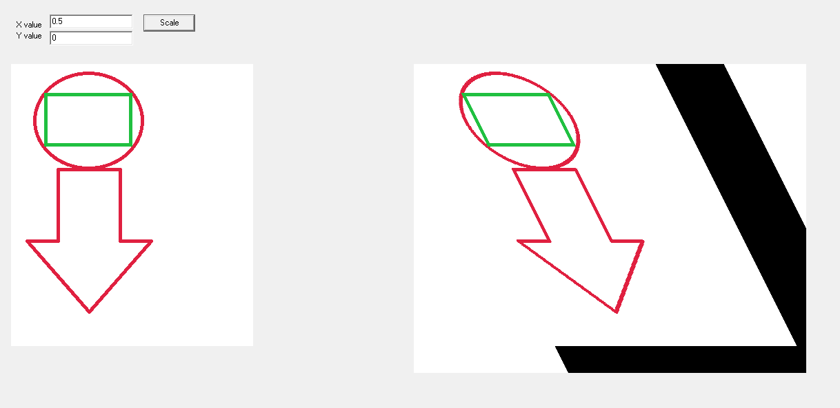

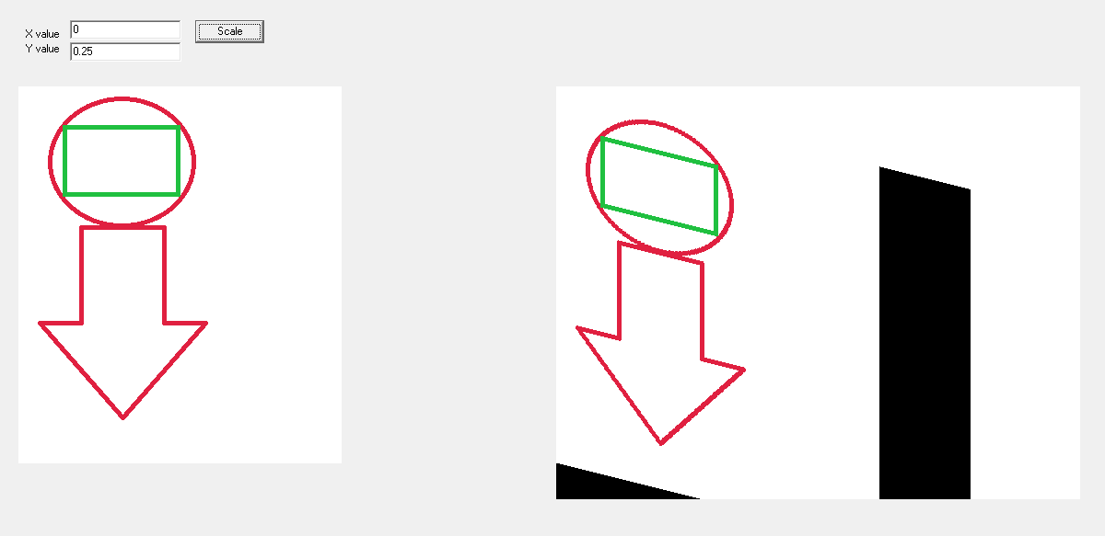

**Conclusion:**

Hence, the sharing was performed using C++ builder.